Client Consent & Waiver Form
I ____________________________ verify that all information is correct and current to the best of my knowledge. I understand that any information provided is for safety purposes and will be kept strictly confidential, unless I provide written consent. I hereby give my consent to receive treatments and I acknowledge and agree that I am doing so at my own risk. My health and safety with respect to such services are my sole responsibility. My decision to receive services is voluntary, and I know of, understand and assume any and all the risks associated therewith.

Please take a moment to read and initial the following information:
- If I experience pain or discomfort during the session, I will immediately inform my therapist. I will not hold my therapist responsible for any pain or discomfort I experience before, during or after the session.
- I understand that the services offered today are not a substitute for medical care.
- I understand that my therapist is not qualified to carry out a medical examination or provide a diagnosis and I agree not to interpret their comments as medical advice.
- I affirm that I have notified my therapist of all known medical conditions and injuries. I agree to inform the therapist of any changes in my health and medical condition. I understand that there shall be no liability on the therapist’s part should I forget to do so.
I understand that treatment is non-sexual in nature.
I understand my medical information and treatment notes may be released to other, third party, health practitioners whom I agree for my therapist to refer me to.
I agree that my therapist will need to disclose my personal information, if required to by law.
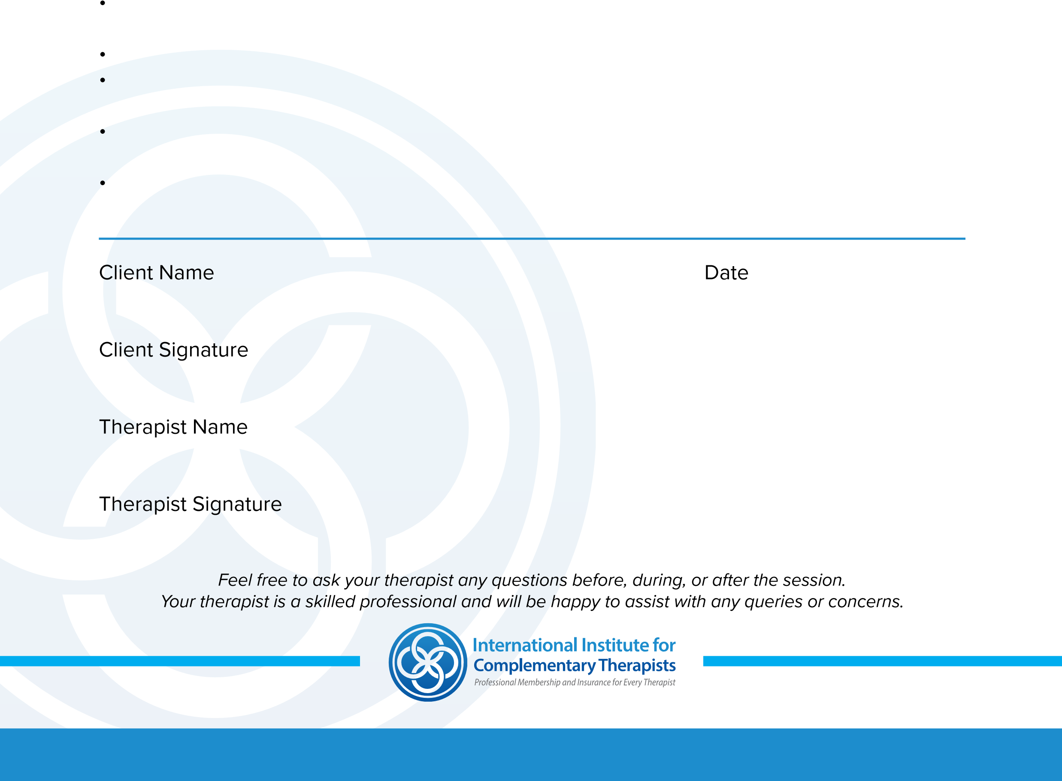
By signing this release, I hereby waive and release my therapist from any and all liability, past, present and future relating to this treatment.

